Corner Grocer Item-Tracking Program

**Introduction**

This document provides a comprehensive overview of the Corner Grocer Item-Tracking Program developed for CS 210 at Southern New Hampshire University. This program is designed to track the frequency of item purchases from a grocery store to aid in inventory management and store layout decisions.

**Program Design**

**Architecture** The program is structured around a main executable that interfaces with users through a console menu. It includes a class**, GroceryTracker**, which handles all data management functions including reading from a file, processing item frequencies, and storing data in a map.

**Data Handling** Data is loaded from a file named **CS210_Project_Three_Input_File.txt** into a **std::map** where keys are item names and values are the counts of each item. This map is utilized to track and display item frequencies and generate histograms.

**User Interface** The interface is a simple console-based menu that allows users to interact with the program through four main options:

1. Search for an item's frequency.
2. Display a list of all items and their frequencies.
3. Display a histogram of item frequencies.
4. Exit the program.

**Functionality**

**Menu Option One: Search for an Item** Allows the user to enter an item name and retrieves the purchase frequency of that item from the data.

**Menu Option Two: Display All Item Frequencies**:

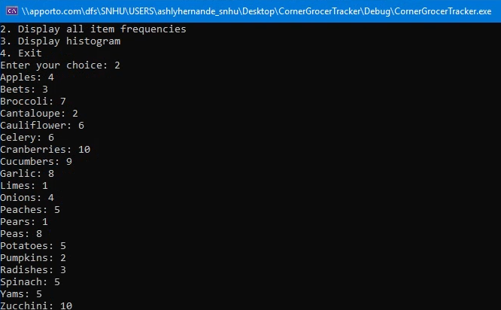

**Menu Option Three: Histogram Display** Shows a visual histogram where each item is represented by a line of asterisks corresponding to its purchase frequency.

**Menu Option Four: Exit** Closes the application.

**Input Validation and Error Handling** Describes how the program handles invalid inputs and errors during file operations. For example, if a non-numeric input is entered or the file cannot be opened, the program will inform the user and allow them to try again.

**Conclusion**

This program effectively utilizes data structures and file handling to provide a useful tool for the Corner Grocer. It was designed with usability and efficiency in mind, ensuring that even users with no technical background can easily interact with it.